Project Management Plan - BAP002

**1. Background and References 1**

1.1. Project Definition 1

1.1.1. Objectives 1

1.1.2. BAP002 features 1

1.1.2. Training Courses 1

1.1.3. Manuals 2

1.2. Client 2

1.3. Site Dependencies 2

1.4. Constraints 3

1.4.1. Time 3

1.4.2. Budget 3

1.4.3. Regulatory Requirements 3

1.4.4. Human Resources 3

**2. Project Roadmap 4**

**3. Project Structure 5**

3.1. Structure and Roles 5

3.2. Project Breakdown Structure 6

3.3. Activity Breakdown Structure 7

3.4. Work Breakdown Structure 7

**4. Supporting Management Activities 9**

4.1. Risk Class 9

**5. Master Plan 10**

5.1. GANTT Chart 10

**6. Technical Quotation 11**

6.1. Costs 11

6.2. Purchasing Plan 11

6.3. Price and Payment 12

6.4 EVA 12

# 1. Background and References

## 1.1. Project Definition

The contract involves the supply of the **BAP002** model equipment for the automated packaging of bottles, including a compressor. This equipment will streamline *Company A*'s packaging processes and enhance efficiency.

The **BAP002** system encompasses the following functions:

* Sequentially feeding bottles from a pallet to the packaging equipment.
* Transporting the bottles to the packaging station.
* Packaging the bottles in cardboard boxes, with the option to select the number of bottles per box from a predetermined list.
* Delivering the boxes to the palletising machine (palletising machine not included in the delivery).

### 1.1.1. Objectives

As *Company B*, we will take care of the **production and** **installation** of the machinery within *Company A*'s premises. In addition, we will provide a **spare parts kit** for the warranty period of one year, ensuring that Company A has access to necessary components for any potential maintenance needs during this time.

We will provide a comprehensive **set of manuals**, including technical, maintenance, and troubleshooting manuals, in electronic format. These manuals will serve as valuable resources for the proper operation and upkeep of the equipment.

Furthermore, we will conduct **training courses** to ensure that *Company A*'s staff is well-equipped to handle the machinery.

The training will cover the necessary knowledge and skills required to operate, supervise, and maintain the equipment effectively.

### 1.1.2. BAP002 features

The **BAP002** system is designed to handle bottles of different sizes, including 200ml, 750ml, and 1000ml. This versatile system exhibits excellent performance capabilities in terms of speed, as outlined below:

* For 200ml bottles: It can process 1000 bottles per hour.
* For 750ml bottles: It has a workload capacity of 600 bottles per hour.
* For 1000ml bottles: It can efficiently handle 400 bottles per hour.

### 1.1.2. Training Courses

We have designed the training sessions to cater to the specific needs of different roles within *Company A*. The training program will be customized as follows:

1. **For up to 10 operators:** We will conduct a comprehensive training session that will last for 5 hours, equivalent to one full day. During this session, operators will gain the necessary knowledge and skills to operate the machinery effectively and efficiently.
2. **For up to 3 supervisors:** To ensure effective supervision and smooth workflow, we have structured a detailed training program spanning 12 hours, spread over two days. This extended session will cover essential topics to equip supervisors with the expertise needed to oversee the operation and address any challenges that may arise.
3. **For up to 4 maintenance technicians:** To impart in-depth knowledge and hands-on skills, we have designed an extensive training session that will extend over 24 hours, divided across four days. This comprehensive program will cover maintenance procedures, troubleshooting techniques, and preventive measures to keep the machinery in optimal condition.

By tailoring the training sessions to each specific role, we aim to provide *Company A*'s operators, supervisors, and maintenance technicians with the necessary expertise to maximise the benefits of the machinery and ensure its long-term performance.

### 1.1.3. Manuals

The manuals accompanying the **BAP002** model equipment serve as invaluable resources for users, providing comprehensive guidance on equipment operation, maintenance procedures, troubleshooting, and safety precautions.

These manuals play a crucial role as valuable resources for users, offering detailed instructions on how to operate equipment, perform maintenance tasks, troubleshoot issues, and follow safety protocols. The aim is to create clear, precise, and user-friendly manuals that enable workers from Company A to efficiently utilize and maintain the equipment.

## 1.2. Client

Our client, *Company A*, is a renowned beverage producer in the industry. With a track record of delivering high-quality beverages, Company A has established itself as a prominent player in the market. As part of their strategic growth plans, Company A has undertaken a new project aimed at expanding and enhancing production capabilities at one of their existing manufacturing facilities.

The primary objective of this project is to increase its production in one of its facilities. By optimizing and expanding their manufacturing operations, Company A aims to meet the growing demand for their beverages and capitalize on new market opportunities.

## 1.3. Site Dependencies

As part of the project, *Company A*, the customer, agrees to provide the following facilities and resources at the project site:

* An area measuring 20x50 square metres, which is flat and well-suited for the installation of the equipment. The area should be adequately illuminated, maintaining a lighting level of 300 lux per square meter.
* A main electrical line with a power capacity of 75 KVA, operating at 380 volts with a tolerance of ± 7%. This electrical supply will be utilised for the functioning of the **BAP002** equipment and the compressor.

## 1.4. Constraints

This sub-clause will list all constraints detected. those dependencies will be under constant monitoring throughout the project lifecycle to detect and mitigate any associated risks. Additionally, contingency plans will be established to address any unforeseen issues that may arise effectively.

### 1.4.1. Time

The project is governed by the agreed-upon installation timeline plus the warranty time, with the span time set as **27 months** long. Any delays encountered during the development phases may have a cascading effect on the overall schedule and installation process.

### 1.4.2. Budget

Financial resources in the amount of €1,080,000.00 have been allocated for this project, and any cost overrun may impact the scope or quality of the final product.

### 1.4.3. Regulatory Requirements

The machinery must adhere to all national and international safety regulations and environmental requirements[1].

### 1.4.4. Human Resources

The project's success relies on the presence of skilled developers, engineers, quality control and safety experts. Any alterations in team composition or availability may have an impact on project timelines.

# 2. Project Roadmap

Company B fully commits to completing its tasks within the agreed timeframes to ensure smooth project execution. The timeline for the project deliverables is as follows:

1. **Production of BP002:** During the production phase, Company B will focus on manufacturing the BP002 equipment according to the agreed specifications and requirements. This involves the design specification, customization, and fabrication of the system, along with the spare part kit.
2. **Site design:** During the site design phase, Company B will be responsible for the layout design, procurement of an electrical panel, and network design. This ensures that the physical arrangement of the equipment, electrical infrastructure, and network connectivity are carefully planned and seamlessly integrated to ensure the optimal functioning of the BP002 equipment at Company A's premises.
3. **Delivery on site:** *Company B* will ensure that the equipment is delivered to *Company A*'s premises within a maximum timeframe of **12 months** from the start of the project. This includes the transportation and logistics to bring the machinery to the designated site.
4. **Installation:** *Company B* will diligently work towards completing the installation of the machinery within **14 months** from the project's initiation. This involves the careful setup, configuration, and integration of the equipment into Company A's facility.
5. **Acceptance:** *Company B* aims to achieve the acceptance of the completed project by *Company A* within a maximum timeframe of **15 months** from the project's commencement. This stage involves thorough testing, validation, and approval of the installed machinery to ensure it meets all specified requirements and performs as expected.
6. **Training:** As *Company B*, we will demonstrate our training programmes, designed to cater to the specific needs of different roles within Company A, including operators, supervisors, and maintenance technicians.
7. **End of Warranty:** *Company B* will provide warranty coverage for the equipment for a duration of **27 months** from the project's initiation. This extended warranty period demonstrates our commitment to the quality and reliability of the machinery, with *Company B* being responsible for addressing any issues or defects that may arise during this timeframe.

# 3. Project Structure

Effective project organisation and governance are crucial for the successful execution and delivery of the **BAP002** model equipment supply project. A robust governance framework has been established to ensure the project's smooth progress and attainment of its objectives, empowering key stakeholders and promoting transparent decision-making.

## 3.1. Structure and Roles

Each team member has clear roles and responsibilities, promoting accountability and efficient coordination within the team.

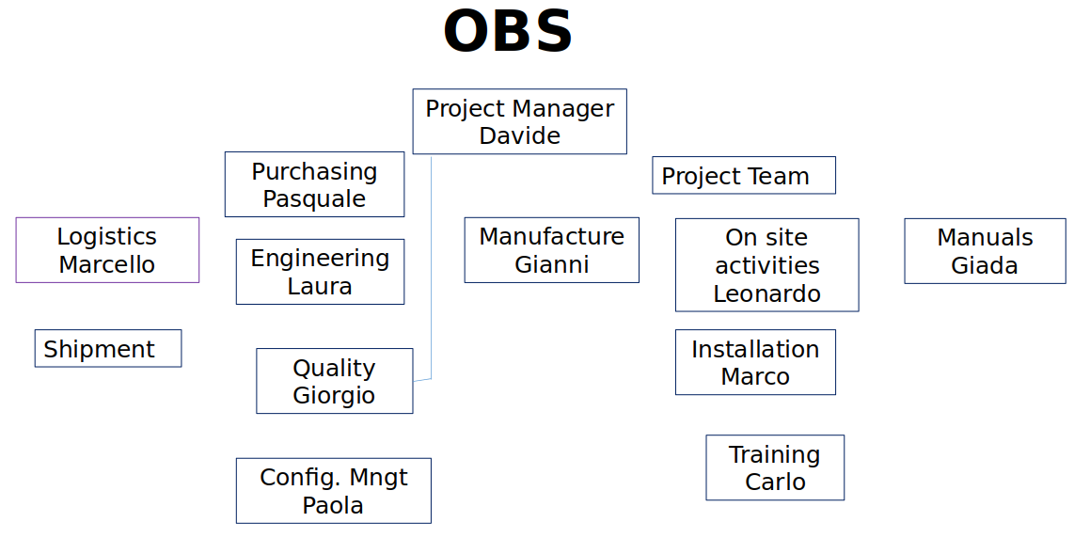

* **Project Manager:** Paolo will be responsible for planning, organising, and overseeing the successful execution of the project, ensuring that it is completed within the scope, budget and timeline defined while achieving the project goals.
* **Quality Assurance:** Giorgio will manage activities and processes to ensure the project meets the established quality standards and requirements. It involves monitoring and evaluating project deliverables, processes and outcomes to identify any deviations or defects by implementing corrective measures to improve quality.
* **Purchasing:** Pasquale will handle the acquisition of goods and services from external suppliers, involving activities such as supplier selection, contract negotiation, and order fulfilment.
* **Engineering:** Laura’s responsibilities include technical expertise, design, engineering analysis, and providing input on engineering considerations for the automated packaging equipment.
* **Configuration Management:** Configuration management involves managing and controlling the configuration of project deliverables. Paola ensures that changes to these items are properly documented, tracked, and controlled to maintain consistency, integrity, and traceability. She oversees activities like version control, baseline establishment, change control, and documentation management to ensure that project assets are accurately configured and meet the required specifications.
* **Project Team**
  + **Manufacture:** As the manufacturing manager, Gianni oversees the production process and ensures that the **BAP002** model equipment for automated packaging is manufactured according to the project requirements and quality standards. He manages the resources, monitors production schedules and ensures that the manufacturing activities are executed efficiently and in a timely manner.
  + **On Site Activities:** Leonardo oversees the installation and implementation of the **BAP002** model equipment at *Company A*'s facilities. He ensures that the equipment is properly installed, integrated with existing systems if applicable, and aligned with the project requirements. Leonardo also manages any on-site troubleshooting, conducts tests and inspections, and addresses any issues that arise during the installation process.
  + **Manuals:** Giada is responsible for creating and delivering comprehensive documentation that accompanies the **BAP002** model equipment.
  + **Training:** Carlo is responsible for providing instruction and guidance to *Company A*'s workers on how to effectively operate and maintain the **BAP002** model equipment. Carlo's responsibility is to develop and deliver training sessions that cover the necessary knowledge and skills required for utilizing the equipment.

## 3.2. Project Breakdown Structure

Our PBS serves as a visual roadmap, breaking down our project's deliverables into manageable components. It provides a clear overview of the project scope, enabling effective planning, organization, and tracking of progress. This section presents the detailed breakdown of our deliverables, supporting alignment and decision-making throughout the project.



* Delivery of n. 1 BAP002 (including Compressor)
* Spare parts kit
* Site set up
* Logistics
* Installation
* Tests
* Manuals
* Training
* Assistance to the Customer people (operators, Supervisors, Technicians)

## 3.3. Activity Breakdown Structure

Presented below is the breakdown structure encompassing the identified activities within the project:

* Detailed Design Specification
* Buy third-party supply
* Equipment Manufacture
* Equipment Customization
* Inside integration
* Test
* set up Shipment
* Shipment
* Site set up
* Equipment Installation
* Support to start
* Acceptance Test
* Warranty
* commision
* Site design
* Manuals Customization
* Project Management
* Production Training
* Training set up
* Training

## 3.4. Work Breakdown Structure

The WBS provides a visual breakdown of our project's work components, tasks, and deliverables. It guides project planning, execution, and control, fostering efficient resource allocation and coordination. In this section, we present the detailed WBS, ensuring a clear understanding of the project scope and facilitating successful project implementation.

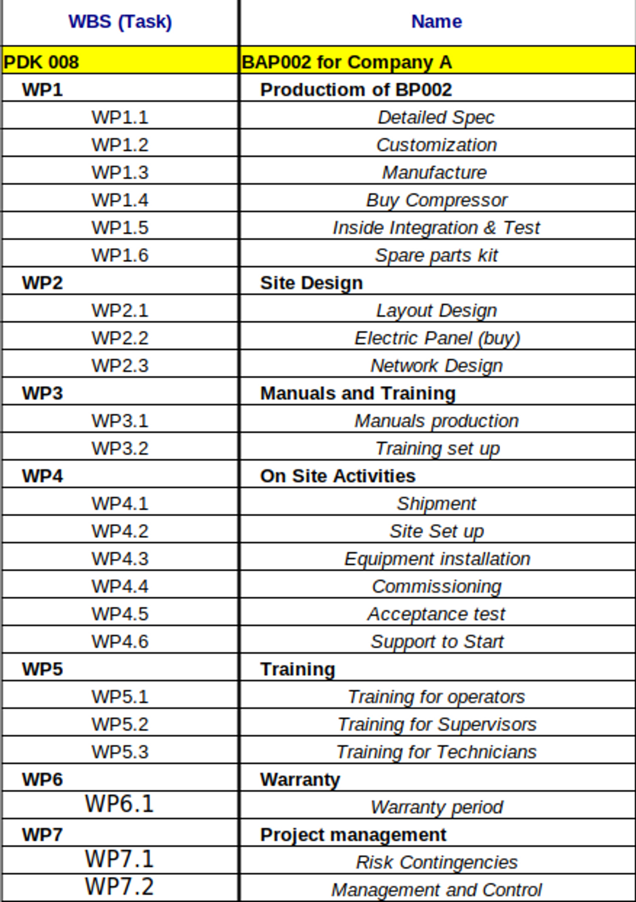

# 4. Supporting Management Activities

## 4.1. Risk Class

The project has been assigned a risk class of Class B after conducting an analysis that considered various factors, including economic conditions, past experiences, project significance, and other relevant characteristics. The following outcomes of the analysis are documented below:

| Territorial diffusion of facilities/services (1 in Genoa, 2 in Italy, 3 in EU, 4 in europe, 5 extra Europe, 0 our agency) | 2 |
| --- | --- |
| Participation in Consortia or RTI / complex subcontractors (A value from 1 to 5 will be assigned depending on the number of actors, the role, the position of the company as principal or agent, etc.) | 0 |
| complexity (1 simple, 2 medium, 3 complex, 4 very complex) | 2 |
| Experience on the projects type(1 already done with success more times, 2 already done with some difficulties more times, already done with more difficulties more times, 4 already done a few times, 5 first time | 2 |
| Economic Value of the Project (1< 50 K euro, 2 between 50 K euro and 500 K euro, 3 between 500 and 2500 K euro, 4 between 2500 and 5000 K euro, 5>5000 Keuro) | 3 |
| Project Margin (1>50%, 2 between 30% and 50%, 3 between 20% and 30%, 4 between 5% and 20%, 5 < 5%) | 3 |
| Importance of the project for the client (1 small relevance, 2 relevant, 3 business critical, 4 life critical) | 3 |
| Customer Importance (A value from 1 to 5 will be assigned based on the strategic importance of the customer) | 3 |
| TOTAL | 18 |

# 

# 5. Master Plan

## 5.1. GANTT Chart

The Gantt chart provides a visual representation of the project schedule, key milestones, and interdependencies. It offers a comprehensive overview of the project's timeline, tasks, and resource allocation.

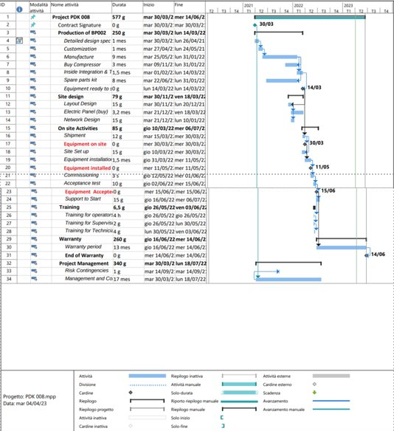

# 6. Technical Quotation

## 6.1. Costs

The Activity Cost section is vital for precise financial planning and effective cost control throughout the project lifecycle, as it provides a comprehensive analysis of the costs associated with each project activity.

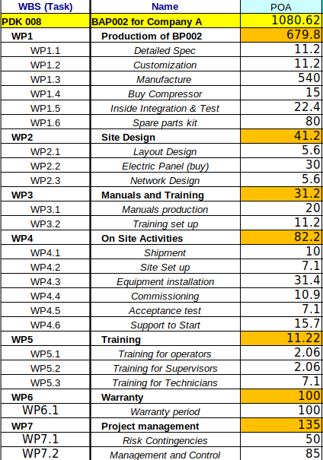

The total budget for the project is estimated to be €1,080,000.00.

## 6.2. Purchasing Plan

It is necessary to make the purchase of a compressor, which will be carried out through *Company C*, at a total cost of 15,000.00 €.

## 6.3. Price and Payment

The price for the project, which includes all the deliverables and services, amounts to **€1’450’000,00**. This comprehensive price covers the equipment, installation, training, manuals, and any other associated costs.

The payment terms for this project are structured as follows:

1. An initial payment of **20%** of the total project cost is required upon placing the order.
2. An additional payment of **20%** is due once the equipment is delivered to *Company A*'s place.
3. An additional payment of **20%** will follow the successful installation of the machinery.
4. The remaining **40%** is to be paid upon the final acceptance of the completed project

## 6.4 EVA

| Revenues | 1,450,000.00€ |
| --- | --- |
| Total Cost | 1,080,620.00€ |
| Gross Margin | 369,380.00€ |
| Mark up | 0,34 |

1. See ISO 9001 and ISO 14001